**DEMO2002 W8 Tutorial**

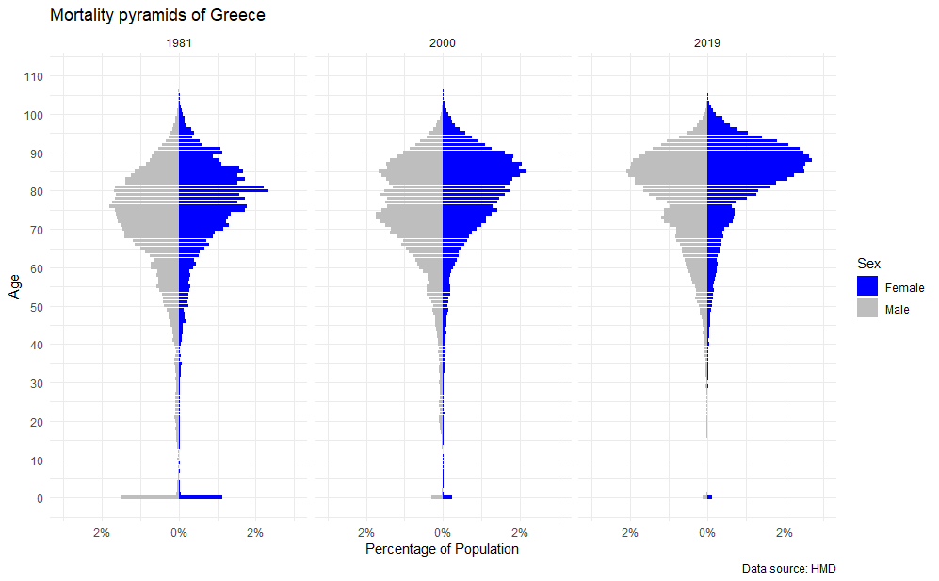

The above figure depicts mortality pyramids for Greece based on Deaths 1x1 data from the Human Mortality Database. It shows pyramids for males and females in the years 1981, 2000, and 2019.

Speaking of the general trends, the people of Greece are tending to live to older ages, on average. In 1981, number of deaths peak at about 77 for males and 80 for females. In 2019, these peaks have shifted to later years – 85 for males and about 87 for females. There is an interesting bimodal-like pattern for male deaths in 2000. While we couldn’t find a direct answer to this, Greece’s experience in political and economic turmoil and declining fertility rates seem to have influenced this pattern.

The plots show marked improvement in infant mortality. In 1981, the infant mortality accounted for more than 1% of the total number of deaths that year, in each of the male and female distributions. Already, infant mortality figure shrinks to less than 0.5% by 2000 and further improvements are observed in 2021. We also see the younger tail ends of mortality shrinking in these decades – that is, less deaths occurring prematurely during their healthy adult years.

Zafeiris and Kostaki (2019) presents a discussion of Greece mortality during 1961-2014. We particularly liked the comparisons made between females and males. For one, Greek female tended to have a smaller “accident hump” — the phenomenon of elevated mortality in impulsive young adults – than males. But they argue that primarily “behavioural and life style” differences account for the mortality patterns between males and females, rather than suicide rates and economic crises in Greece, which preceding literature had touched on.

**References**

Zafeiris, K.N. and Kostaki, A. (2019) ‘Recent mortality trends in Greece’, *Communications in Statistics - Theory and Methods*, 48(1), pp. 112–126. Available at: https://doi.org/10.1080/03610926.2017.1353625.